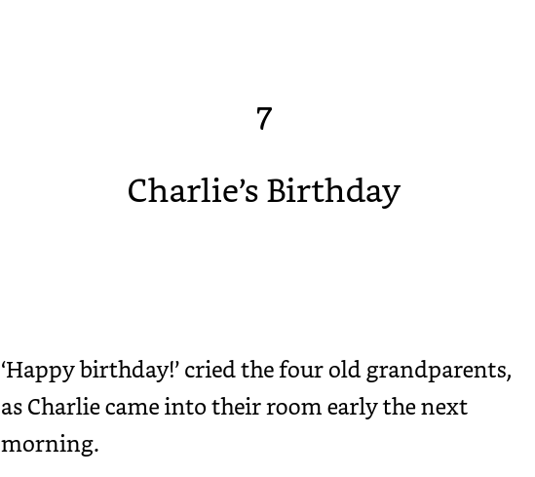
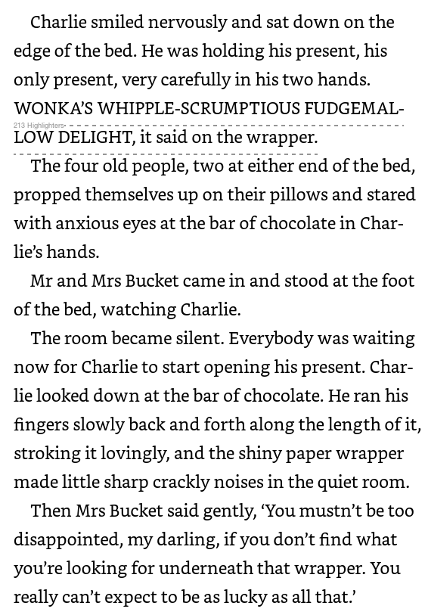
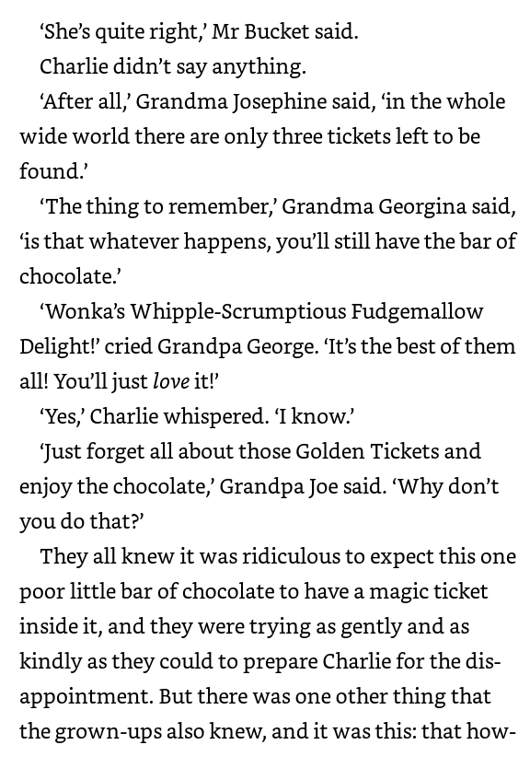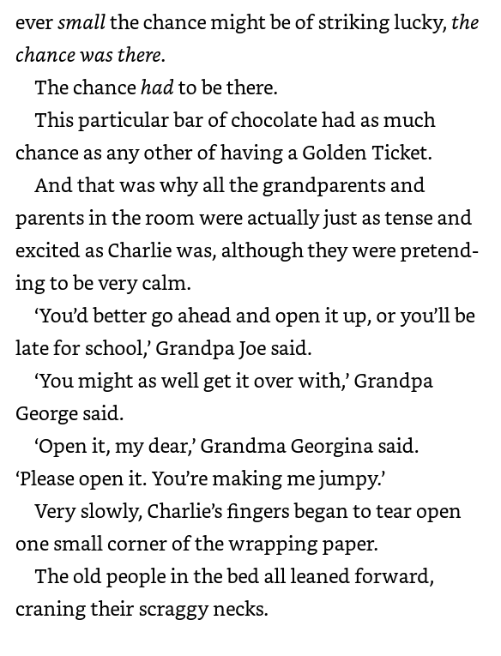
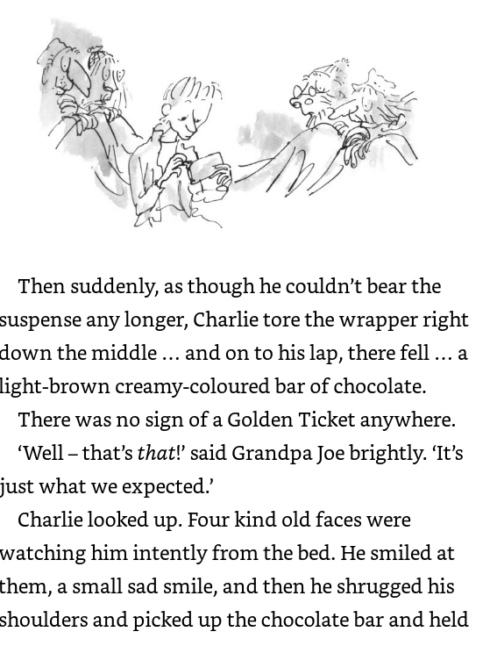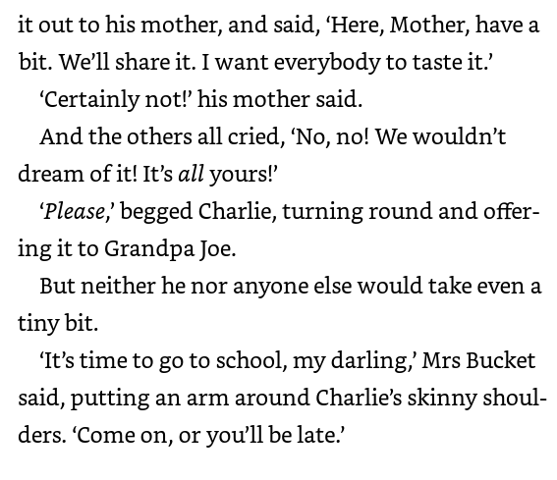
Monday 22nd February

Can I retrieve information?

1)Why did Charlie wake up early?
2)What was the first thing he did on his birthday?
3)How many presents did Charlie have?
4) Find and copy one word that tells you how Charlie smiled
5) Why do you think he smiled that way? Why was he feeling that way?
6)Why did Charlie only have one present?
7)What had he got for his birthday?
8)Why were they all excited for him to open his present?
9)Why would Charlie be taking his time to open his present?

Tuesday 23rd February

Can I retrieve information?

1)How does his mum prepare him for opening the chocolate bar?
2)How many tickets are there left to be found?
3)What does Grandpa George think the best chocolate bar is?
4)Why does Grandpa Joe say to forget about the ticket and enjoy the chocolate?
5)Why were they still excited?
6)Why does Charlie need to hurry up and open the bar?
7)How did the way Charlie opened the bar differ from how he had previously been holding it?
8) Why do you think that is?

Wednesday 24th February

Can I retrieve information and infer meaning?

1) What happened when he opened the chocolate bar?
2) Why do you think Charlie offers to share his chocolate bar?
3) How does his offering to share his chocolate differ from previous birthdays?
4) What is Charlie trying to hide behind his smile?
5 Why did no one want any of Charlie’s chocolate bar?
6) Why does Charlie need to leave?
7) Who reminds Charlie it is time to go to school?
8) Would you like Charlie as a friend? Why?

Thursday 25th February

Can I summarise a chapter?

Summarise the events that happened in Chapter 7. Answer these questions to help

What happened?
Why did they happen?
Where was the chapter set?

Friday 26th February

Read for pleasure – read you own book with a toy, a pet or an adult. Enjoy escaping the world and diving into a book.

