Possible ideas to try at home for ‘The Very Lazy Ladybird’
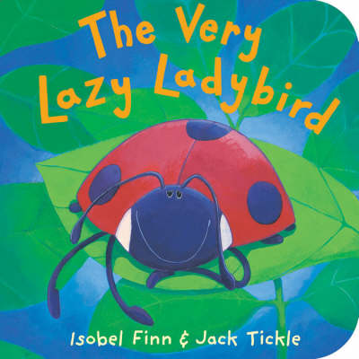
If you don’t have a copy of the book, you can listen to the story here: The Very Lazy Ladybird - YouTube

Literacy
- Before reading the book, look at the cover and think about what the book might be about? What does the word ‘lazy’ mean?
- What other animals could the ladybird meet? What would they do to keep the ladybird awake?
- Write a list of the animals the ladybird met on his journey. - Writing template in paper pack or online.

Maths
- Using a blank outline of a ladybird, can you use raisins/playdough/fingerprints to make each side have the same amount?
- Can you make up some simple addition and subtraction number stories using ladybirds. For example, there were 5 ladybirds on a leaf and another 2 ladybirds joined them. How many ladybirds are there altogether?
Physical Development
- Can you move like some of the creatures in the books?
- Practise your scissor skills using the cutting out sheet in the paper pack or online.
Knowledge and Understanding of the World
- How many legs does a ladybird have? Do you know any other creatures that have the same number of legs?
- Can you find out about the life cycle of a ladybird? How many stages does it have?
- Can you spot on ladybirds on one of your walks? What other minibeasts can you find aswell?
PSED
- Why do you think the ladybird was lazy? Is it good to be lazy?
- Describe your perfect lazy day. Talk with your adult about it or write it down or draw a picture showing what you would do.

Communication and Language
- The author uses lots of different words to describe how the animals move. Can you think of other words to describe how the animals might move? (For example: leap can also mean jump)
- Can you learn the 5 little ladybugs song? Sing it to a family member.

Creative
- Can you learn one of the ladybird songs and make up some actions to it?
- Can you make a 3D ladybird using a toilet roll tube and paper?
- Can you paint or draw your own ladybird?
- Can you create a picture of the forest where the ladybird lives? Maybe you could use different materials to make a collage of the forest (see below for example)
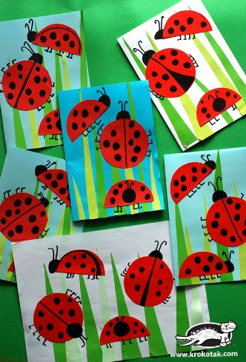
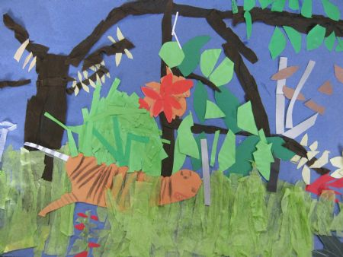
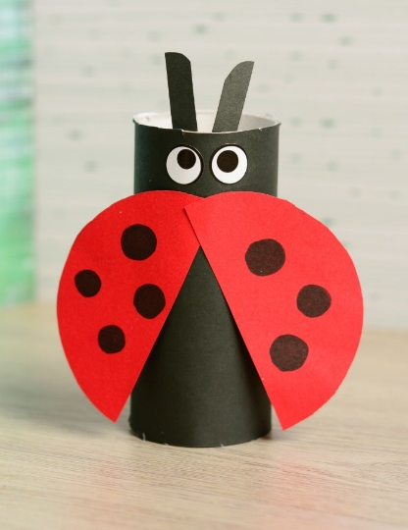

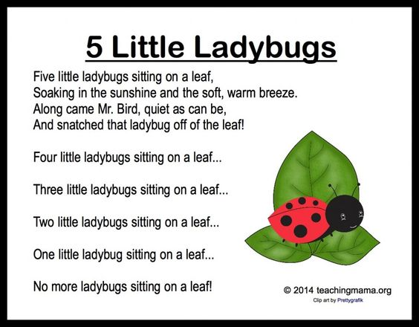
Ladybird Ladybird | Nursery Rhymes | Original Song By LittleBabyBum! - YouTube link for a ladybird song

