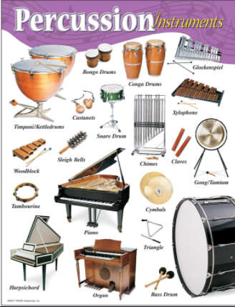
Music –Year 5 Week 8 Rhythm –

Can I structure and perform

a piece inspired by West

African drumming?

Use the link below to find your
first lesson all about rhythm:

https://classroom.thenational.academy/lessons/to-structure-and-perform-a-piece-inspired-by-west-african-drumming-6gv3er

Or search: Oak Academy KS2 music Rhythm 3 Lesson 2

Listen carefully and have fun!

