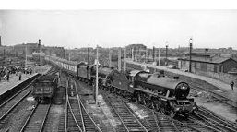
Easter Oracy Homework
This half term we have been learning all about the history of trains and how the arrival of the railway changed Crewe.
Over Easter, discuss with your family and friends how the trains changed Crewe.
Think about the human features which changed and how people’s lives changed.
When we get back to school after the Easter break we will discuss what you talked about and if you went to any of the place which have changed due to the introduction of the railways.
