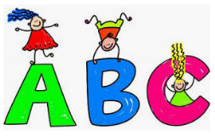
Let’s have fun with Reading and Phonics!
- Play sound games such as `I spy`.
- Word treasure hunt… hide a scrunched
up paper with key words, the children
have to find them and read the word aloud.
- Play snap with letter cards to help with letter
Recognition.
- Give your child words with the same initial
sound and one different…can they find the
odd one out?? E.g. cup/cat/man
- Write with chalk
- Mark make with shaving foam (in a tray)
- Water on the outside wall using a paint brush
- Free online Phonics games
https://www.phonicsplay.co.uk/
https://www.bbc.co.uk/cbeebies/shows/alphablocks
- Read, read, read….school books, magazines,
Shopping lists bedtime stories.

