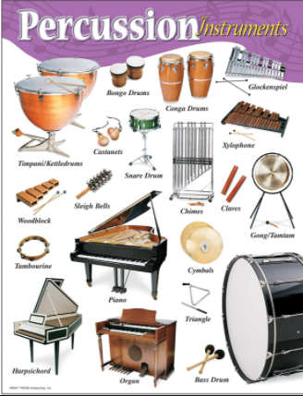
Music- Wednesday 13th January –
Year 5 Week 2 Timbre –
exploring different sounds

Use the link below to find your
first lesson all about percussion:

https://classroom.thenational.academy/lessons/exploring-different-sounds-c9k3gc

Or search: Oak academy ks2 music exploring different sounds

Listen carefully and have fun!

