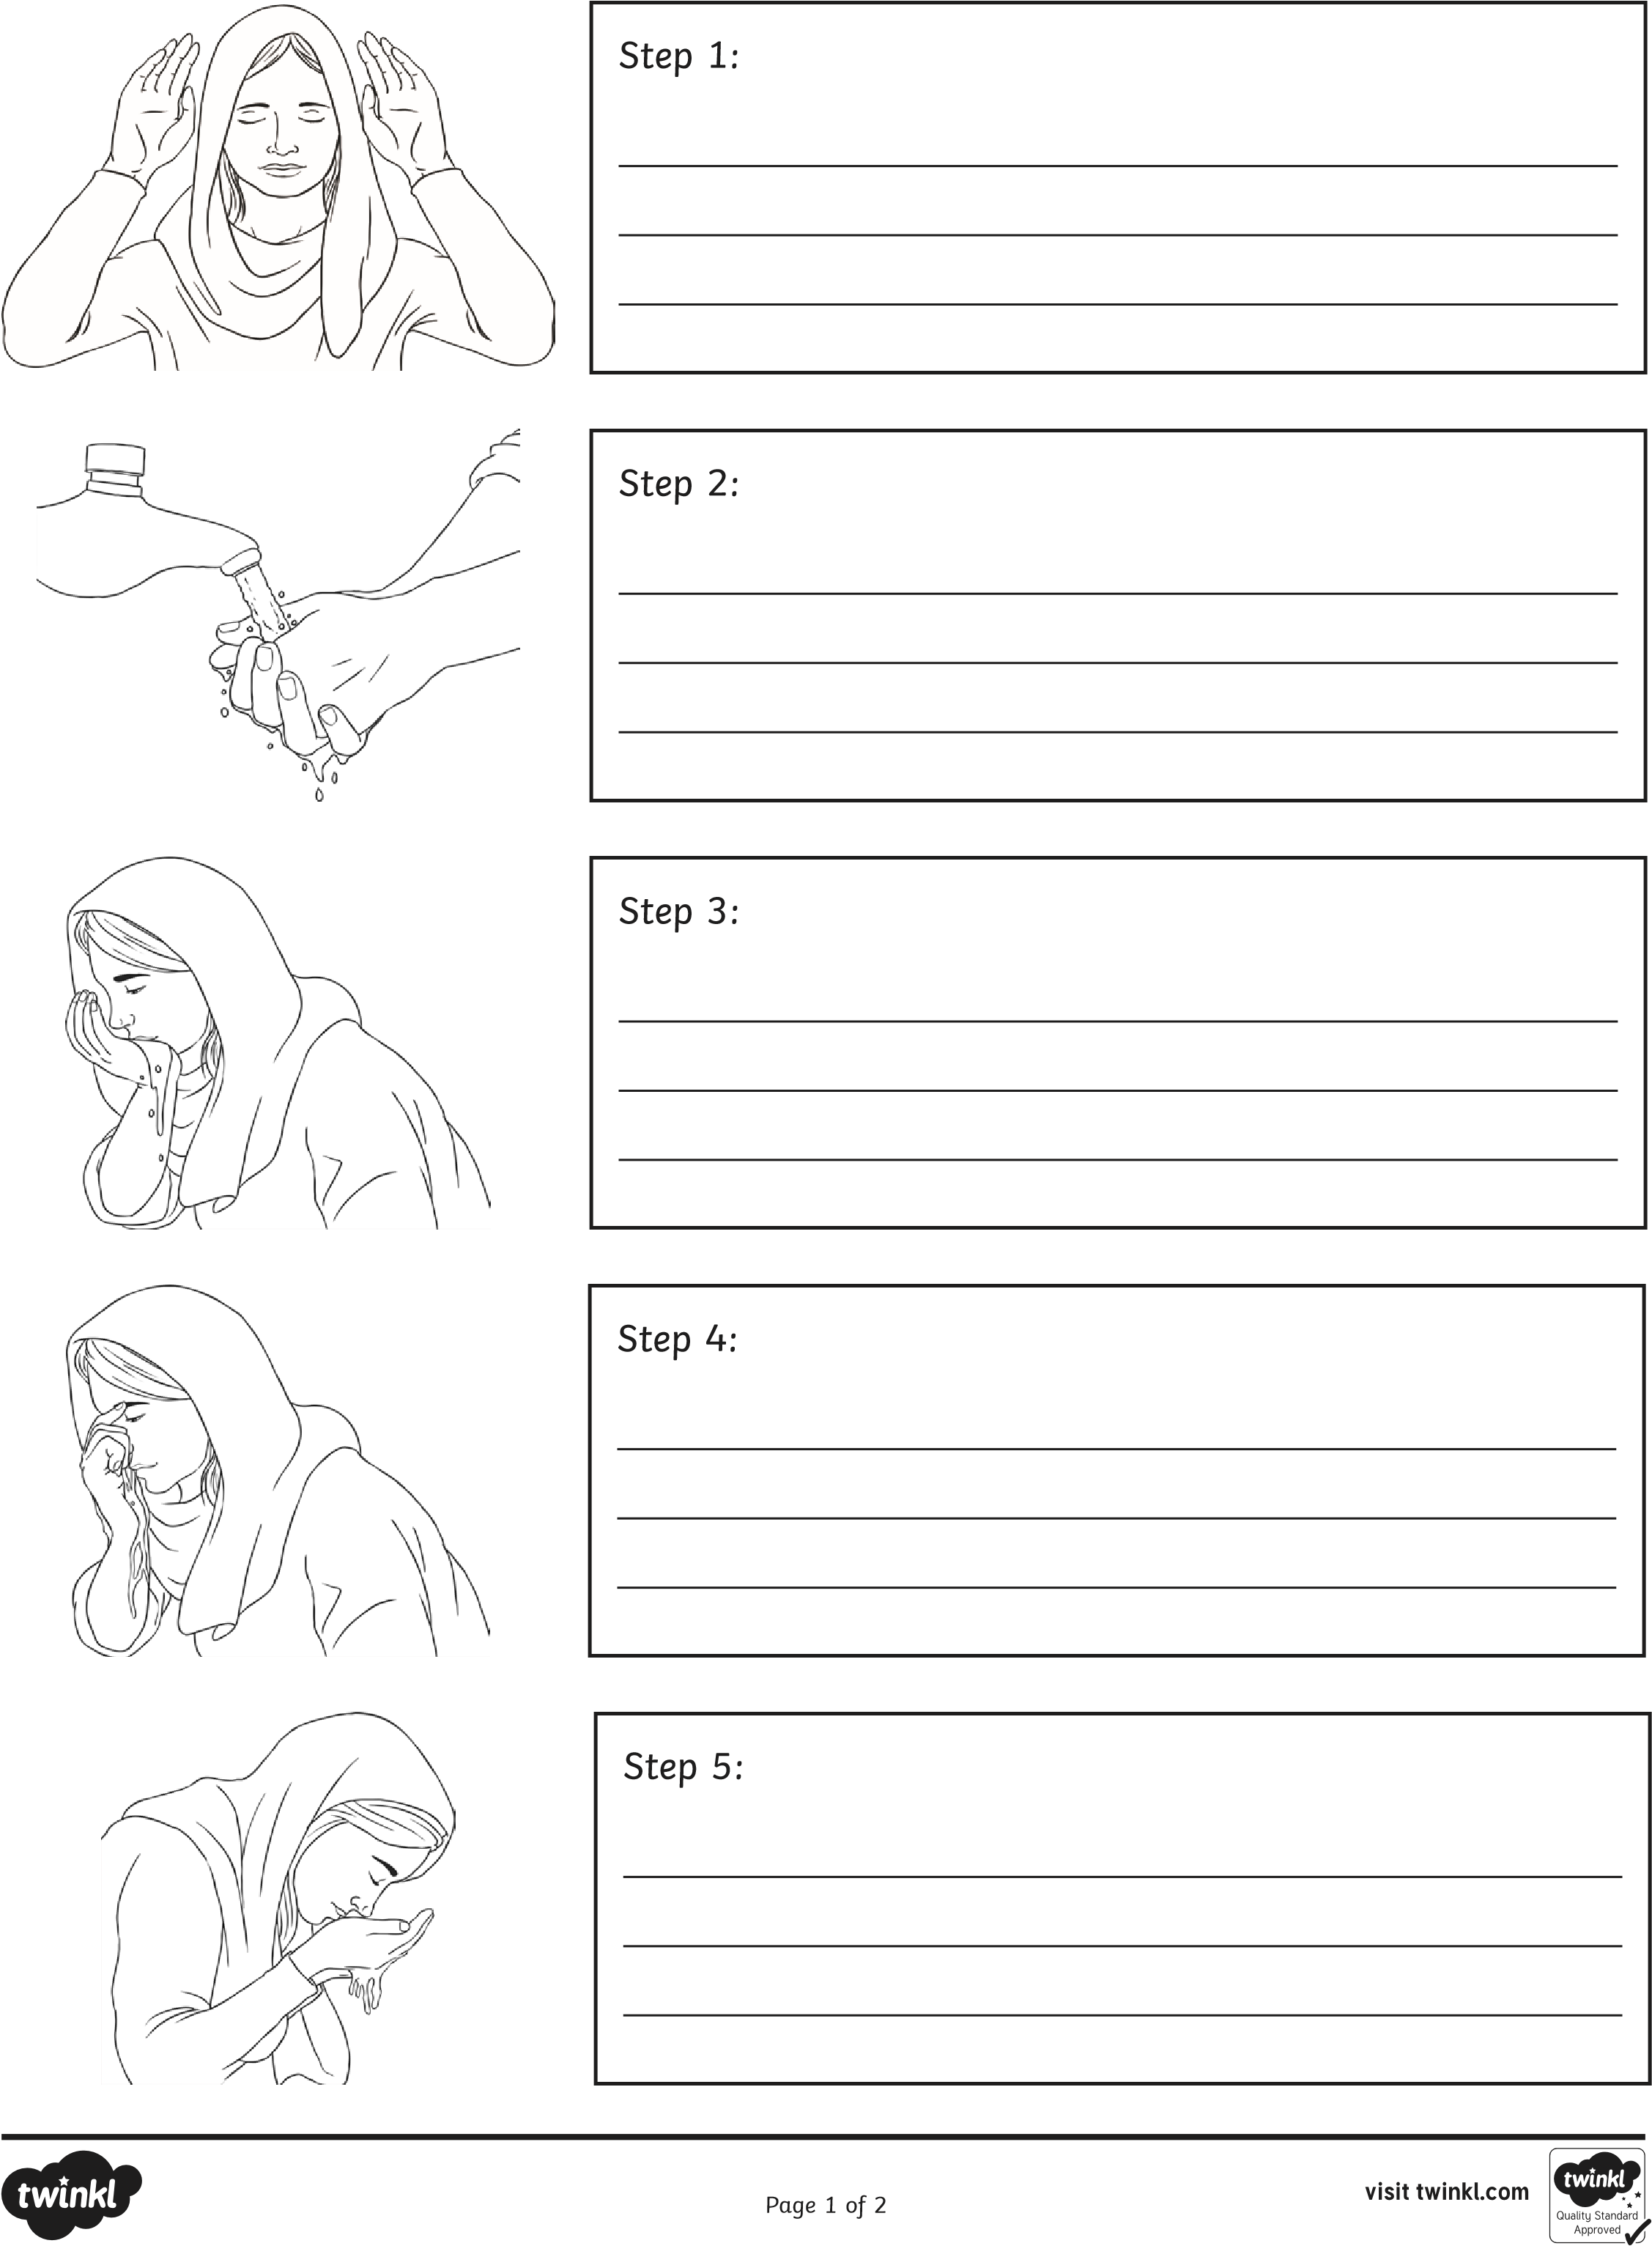

|  |  |  |
| --- | --- | --- |
|  | |  | | --- | | Step 6: | |



|  |  |  |  |  |  |  |  |  |
| --- | --- | --- | --- | --- | --- | --- | --- | --- |
|  | | | | |  | | --- | | Step 7: | | | | |
|  | | | |  | | --- | | Step 8: | | | | |
|  | |  | | --- | | Step 9: | | | | |
|  | | |  | | --- | | Step 10: | | | | |