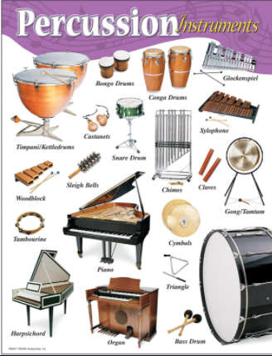
Music –Year 5 Week 4 Timbre –
Developing body percussion Part 2.

Use the link below to find your
fourth lesson all about percussion:

https://classroom.thenational.academy/lessons/developing-body-percussion-part-2-6cw6cr

Or search: Oak Academy KS2 music Developing body percussion Part 2.

Listen carefully and have fun!

