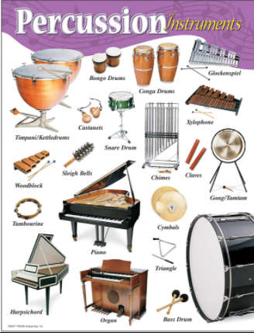
Music –Year 5 Week 5 Timbre –
Composing a body percussion piece.

Use the link below to find your
fifth lesson all about percussion:

https://classroom.thenational.academy/lessons/composing-a-body-percussion-piece-6nk38d

Or search: Oak Academy KS2 music Composing a body percussion piece.

Listen carefully and have fun!

