P.E lessons - Week 5 - Thursday 4th February- Balance
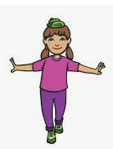
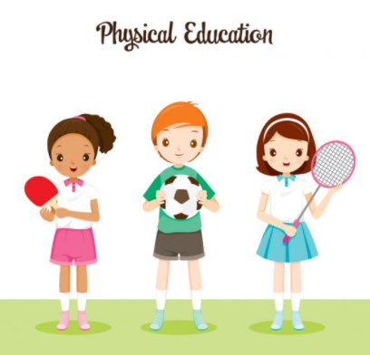
Can I balance an object on my head, move around while balancing an object on my head, balance my object on different parts of the body and balance my object on my head while balancing on one leg?

YOU WILL NEED:

Something to balance on your head. Socks, bean bags or anything soft that won’t break. Space to move around safely. Approx. 35 minutes

Warm up – 30 second challenge – can you do 15 star jumps and 5 sit-ups in 30 seconds?
- Balancing an object on your head/shoulder - Using a soft object or socks practice balancing it on your head without dropping it. Then count how many seconds you can balance the object on your head without dropping it. Have 3 more goes to try and beat your score! Can you beat 15 seconds? To simplify use an easier object to balance.
- Sitting down to standing up with an object balanced on your head/shoulder – Start sitting down and balance an object on your head. Can you stand up without the object falling off? See how many times you can repeat the process without your object falling off. Can you repeat this multiple times to make it more challenging.
- Moving with an object balanced on your head/shoulder – Try moving around in a small space while keeping the object balanced on your head. Can you walk around in a circle? Can you beat 10 seconds? Can you make different shapes whilst walking.
- Balancing objects on different body parts-Try and balance your object on different parts of your body. For example, your elbow or your foot. See if you can come up with your own ideas as well. Count how many different body parts you balance your object on for 10 seconds or more? Can you balance your object on 3 different body parts? How long can you balance it for?
- Balancing on one leg – Try standing on one leg for as long and you can. Swap legs and see which leg you can balance on for the longest. Put your arms out to help you balance. Can you Balance on one leg for 5 seconds without dropping your object? You are approaching Ks3 work if you are able to complete this!! WELL DONE.

Have fun!

