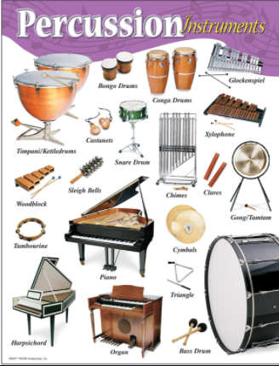
Music –Year 5 Week 6 Timbre –

Compose and perform your
body percussion piece.

Use the link below to find your
last lesson all about percussion:

https://classroom.thenational.academy/lessons/compose-and-perform-your-body-percussion-piece-crtp6e

Or search: Oak Academy KS2 music Composing and performing your body percussion piece.

Listen carefully and have fun!

