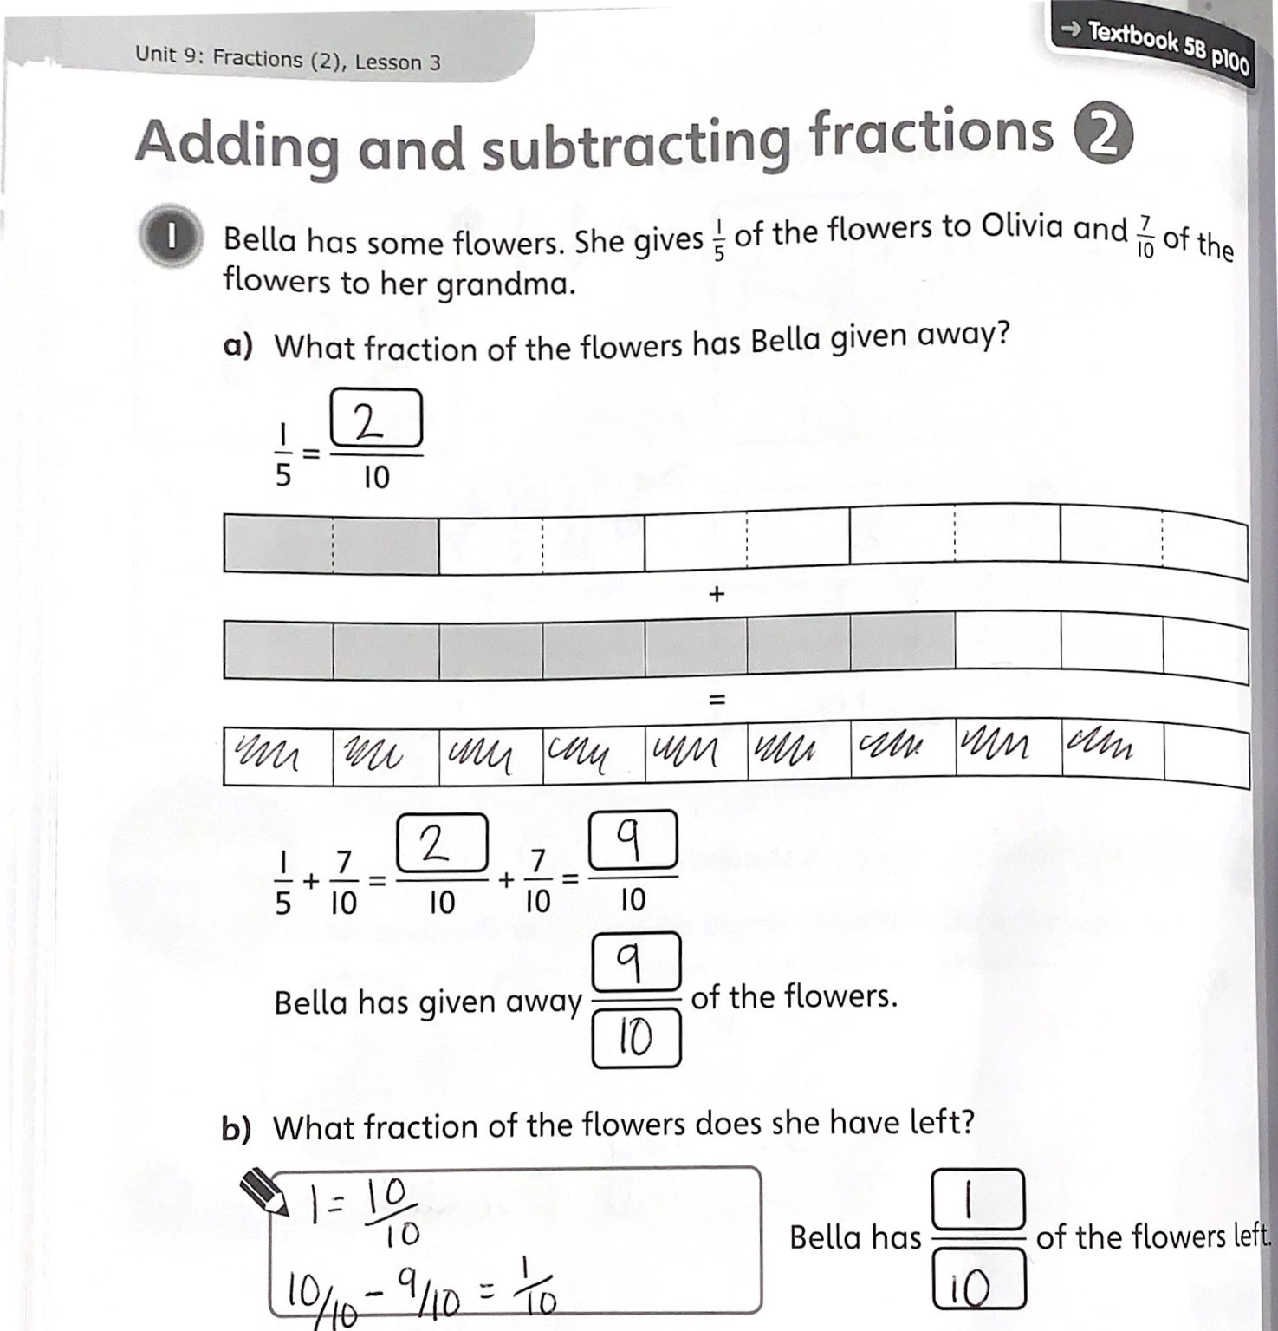
Complete the following fraction calculations.
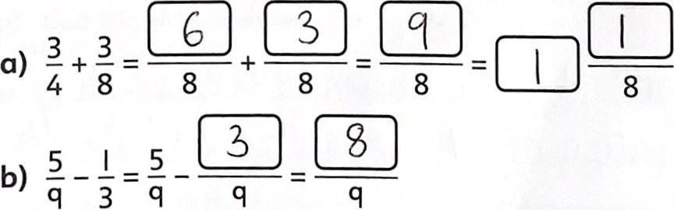
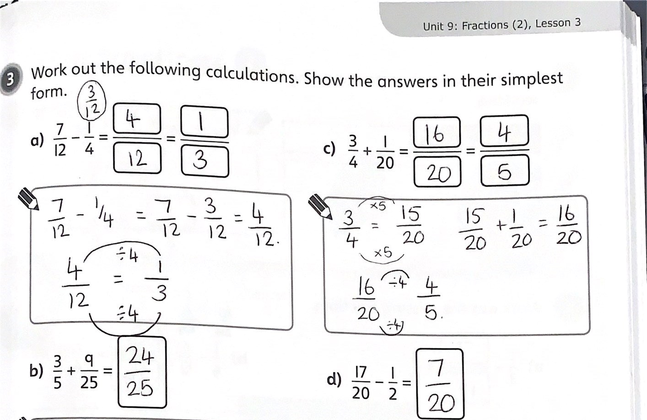
15 + q  25 25 - 25 | 20 10 20
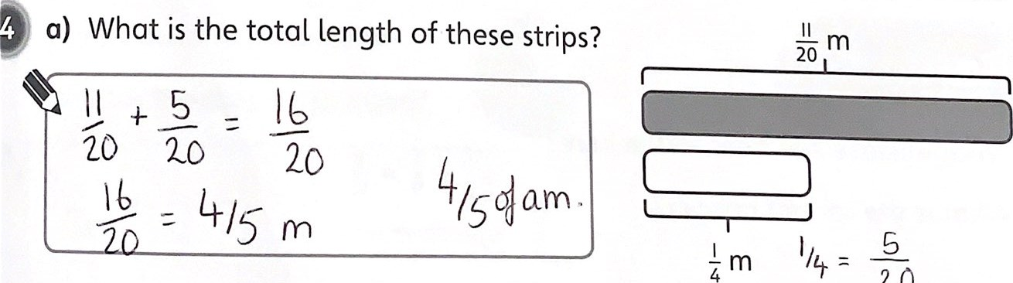
20
b) How much shorter is the white strip than the grey strip, in metres?
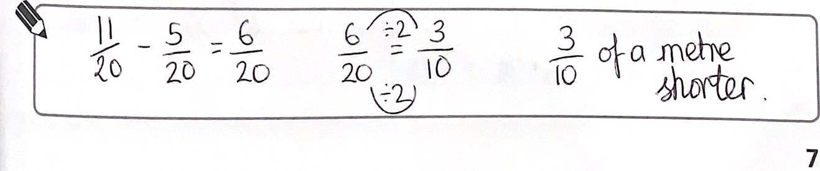
75
Unit 9: Fractions (2), Lesson 3
What is the total of the following fractions? Explain the steps in your
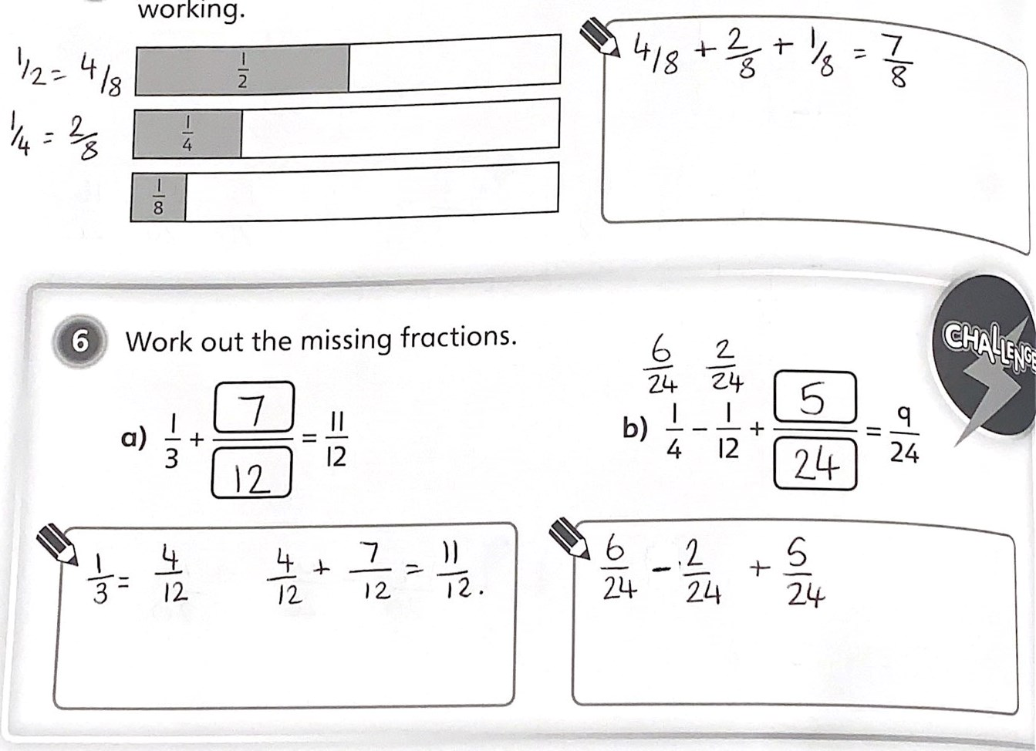
working.
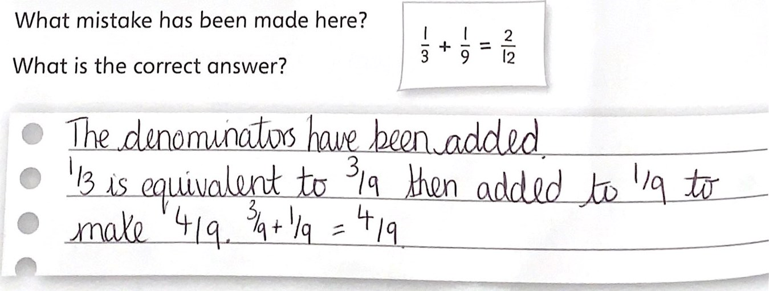
76

