

Are Online Games and Apps Safe for Your Children?

**Cledford Primary School & Gainsborough Primary & Nursery School**

**A Federation of Cheshire East Primary Schools**

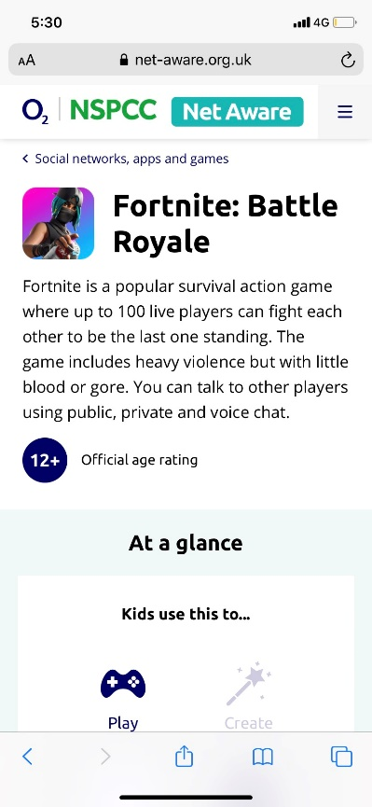

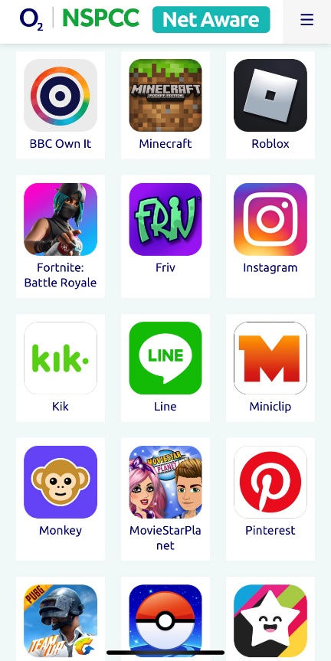

1. Type ‘NSPCC Net Aware’ into Google.
2. Click on the App you want to find out more about.



1. Find a quick summary of what the game or App is about

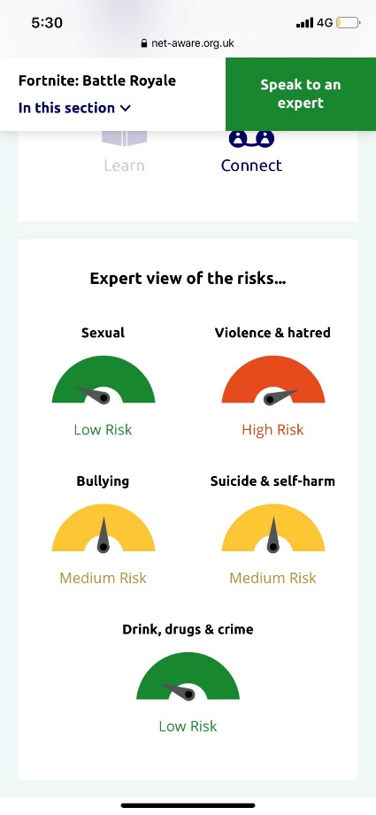

NSPCC Net Aware is a fantastic tool for parents to learn more about how safe games and Apps are for children.

1. Each category is rated:

Low risk = green

Medium risk = yellow

High risk = red

1. Find out the age rating