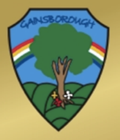
Gainsborough Primary & Nursery School
VOCABULARY PROGRESSION MAP

Focus | Early Years | Year One | Year Two | Year Three | Year Four | Year Five | Year Six
Must | Art  Craft  Mix  Dark/Light  Draw  Create  Design  Plan  Paint  Space  Colour Names | Collage  Materials  Texture  Outline  Pattern | Sculpture  Portrait/landscape  Background/ foreground  Straight/wavy  Thick/thin  Tone | Colour wheel  Carve  Charcoal  Line sketch  Shading  Edit | Blur  Smudge  Reflection  Shadow  Scale  Tint | Distortion  Perspective  Proportion  Vision | Contrast  Comparison  Abstract  Horizon  Scale  Proportion
Could | Observe  Pressure | Overlap  Repeat | Designer  Technique | Hue | Hatching/cross hatching | Architect | Critique  Evaluate  Impressionist

