Monday 5th January
Here are some activities to complete and enjoy together at home with your child today.
If you would like to send the tasks to school when we return or email a photograph to school, we would love to see them.

- Scan and play this Fred game
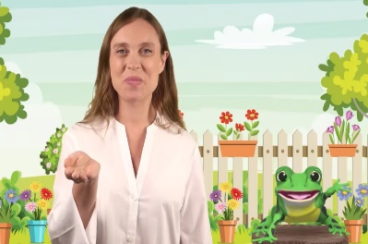


- Write the sentence
I can in the snow.

- Make a snowman.
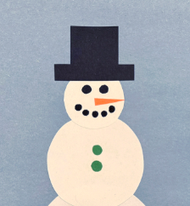
- Draw a snowman and name the shapes.

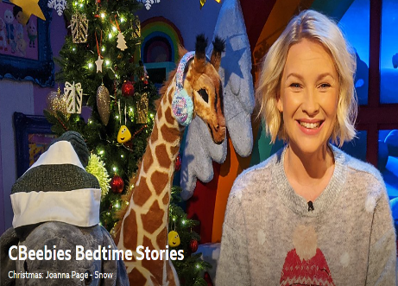
- Listen to a snowy story
https://share.google/ifnNLBrrH3T5JYZJu

