Tuesday 6th January
Here are some activities to complete and enjoy together at home with your child today.
If you would like to send the tasks to school when we return or email a photograph to school, we would love to see them.
- Scan and play this Fred game
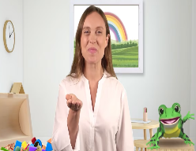


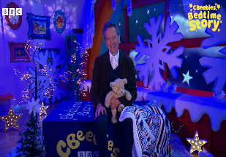
- Snowy Story Time
https://youtu.be/JvP2ABMifqc?feature=shared

- Writing - winter words
Think of words linked to snow (cold, ice, white, melt). Write them down.

- Maths
Draw snowflakes on paper and count them.
Circle the biggest and smallest.
Write the number to match the amounts

- Understanding the World
What Happens to Snow?
Bring a small handful inside and watch it melt.
Talk about changes: solid → water.

- Weather Watch
Look outside together at different parts of the day and discuss the weather.
Is it snowy, icy, cloudy, or sunny?

- Physical Development
Winter Moves
Pretend to:
Waddle like a penguin
Stretch like a tall snowman
Tiptoe on icy ground
Then complete a Danny Go song
https://youtu.be/c9YiakkdS8k?feature=shared

- 💬 Communication & Language
Talk Time
Ask:
How does snow feel?
What clothes do we wear in winter?
What is your favourite thing about snow?

