Tuesday 6th January
Good morning, Nursery!
Here are some activities for you to complete today.

- Practise writing your name. Don’t forget pinchy fingers!

- Practise your counting to 10 with the singing walrus.

https://www.youtube.com/watch?v=HkkYaj0m6cg&list=RDHkkYaj0m6cg&start_radio=1

- Draw a snowman. Remember to add a carrot nose and buttons.


- Have fun in the snow

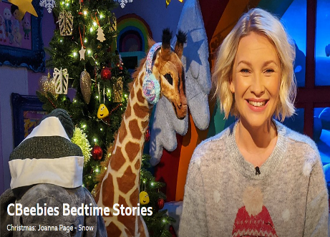
- Listen to a snowy story
https://share.google/ifnNLBrrH3T5JYZJu

