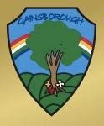
Gainsborough Primary and Nursery Academy
Curriculum Brochure for Parents and Carers
English  Key vocabulary: nouns, adjectives, verbs, subordination, co-ordination, question marks, apostrophes and expanded noun phrases.  What pupils will learn: how to form nouns using suffixes such as –ness, -est, -ful and less.  They will also learn how to use subordination (using when, if, that, because) and use co-ordination (using so, or, and, but.  History  Key vocabulary: past, present  What pupils will learn:  In history we shall be learning how the Cenotaph in Crewe helps us remember the past and its significance to the town.  I know about the lives of significant individuals who have contributed to national achievements.  Geography  Key vocabulary: London, Egypt, Cairo, Northern Hemisphere, Southern Hemisphere, Equator, Globe  What pupils will learn:  Can I label the Equator, Northern and Southern Hemispheres on a world map?  Where would I locate the hottest and coldest countries in the world?  Why would Egypt be a hot country?  Can I compare the weather in England to Egypt during the summer and winter months? (FIELDWORK)  What are human and physical features?  What are the key physical and human features of England? | Year 2  Autumn Term  Focus texts:  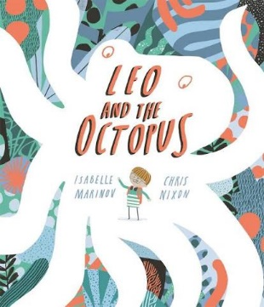  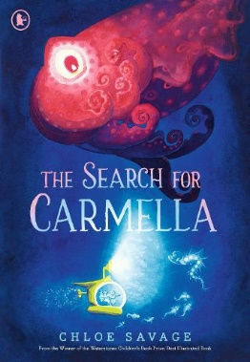  Educational Visits  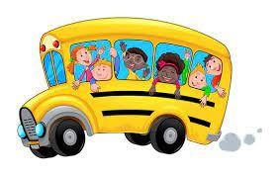  Autumn 1:  12th October 2026  Crewe memorial in the heart of the town- history and geography field trip  Free.  Stay and Read  20th October- 8.50-9.20am | Maths  Key vocabulary: Addition, subtraction, take away, minus, more than, less than, sequence, order, tens, ones, compare, digit, subtract, total, array, times tables  What pupils will learn:  In maths this term the pupils will continue to work on all four mathematical operations (addition, subtraction, multiplication and division).  They will also learn about place value, more and less, greater and less than and money.  Science  Key vocabulary: materials, wood, plastic, metal, paper, cardboard, glass, brick, use, suitability, compare, twist, bend, stretch, squash, push, pull, shape, flexible  What pupils will learn:  In science this term we shall be learning about materials. Children will be exploring different materials and their uses. They will also be looking at making a waterproof coat for a character in one of our stories.  I know the names of everyday materials.  I know each material can be used in different ways. I know some materials are not suitable for jobs and why.  I know some materials can have their shapes changed by twisting, squashing, bending and stretching them.
Design Technology -Sewing a pouch  Key vocabulary: needle  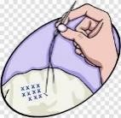  running stitch  sew template thread  What pupils will learn:  To learn to sew using a running stitch – the children will make a pouch.  Sew a running stitch with regular-sized stitches and understand that both ends must be knotted. Prepare and cut fabric to make a pouch from a template.  Use a running stitch to join the two pieces of fabric together.  Decorate their pouch using the materials provided.  Art  Key vocabulary: form, space, colour, texture, line What pupils will learn:  In art, the children will study the work of Andy  Goldsworthy and create images inspired by his work. To know about artist Andy Goldsworthy and make links with their own sculpture work.  To use a range of materials creatively.  To design and make images and forms from nature. To use sculpture to develop and share their ideas, experiences and imagination.  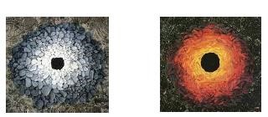 | PSHE including well-being and mental health  Key vocabulary: nervous, excited, cross, angry, happy, right, wrong  What pupils will learn:  To know the school rules and values.  To understand that families should offer love and support.  To know families may be made up of different people.  I will consider friends’ thoughts and feelings.  I understand that situations happen in friendships and an adult can help to resolve them when needed.  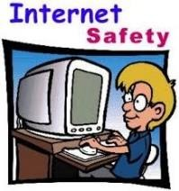  Computing  Key vocabulary: impressionist, pointillism, digital art, patterns, portfolio  What pupils will learn: To create a digital art piece in an Impressionist style. To create a digital art piece in a Pointillism style. To create a digital art piece that is in the style of Piet Mondrian's work. To create digital art patterns in the style of the Arts and Crafts movement. To create a portfolio of digital art.  RE  Key vocabulary: Bible, important, Christian, New Testament, Old Testament  What pupils will learn:  In RE the children will explore that the Bible is a Christian’s holy book and identify different kinds of genre. | Music  Key vocabulary: tempo, dynamics, timbre, percussion, rhythm  What pupils will learn:  The children will learn to listen to music with a focus on a particular musical element.  I can listen to and recognise instrumentation.  I can recognise and understand timbre changes in the music I listen to  I can copy longer rhythmic patterns on untuned percussion instruments keeping a steady pulse. I can successfully combine and layer several instrumental and vocal patterns within a given structure.  I can use my voice expressively when singing, including the use of basic dynamics.  I can sing short songs from memory, with melodic and rhythmic accuracy.  PE- Monday and Thursday– Dance/Throwing and catching  Key vocabulary: dance, twist, turn, leap  What pupils will learn:  I can perform dances using simple movement patterns.  I can extend my throwing and catching skills independently and with a partner.  Please ensure your child has their school PE kit in school at all times, and all items are labelled.  Children also need a water bottle in school daily.

